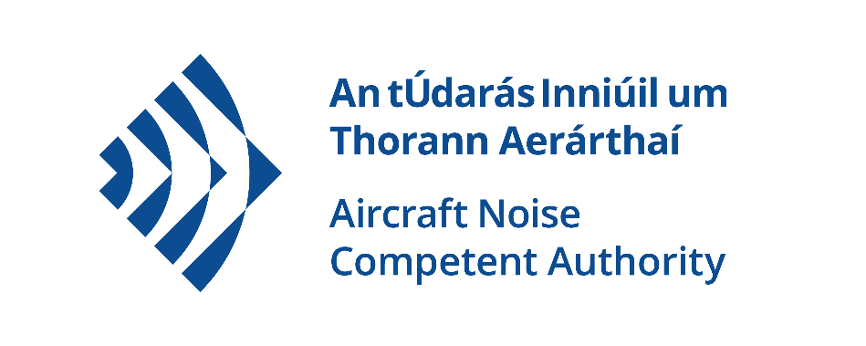

Aircraft Noise Competent Authority

Data Protection - Privacy Statement

August 2021

Table of Contents

Introduction 3

Information collected by ANCA 3

Requirement for a Privacy Notice 3

What personal data do we collect? 4

General correspondence 4

Public Consultation Processes 4

Sharing Information 5

How your Personal Data will be protected. 5

Legal and Regulatory Obligations 5

How long do we keep it? 5

Your Rights 6

Data Protection Contact Details 6

Complaints procedure 6

## Introduction

Fingal County Council (the Council) is responsible for the provision of an extensive range of public services, including those by the Aircraft Noise Competent Authority (ANCA).

ANCA is the regulatory authority responsible for ensuring that noise generated by aircraft activity at Dublin Airport is assessed in accordance with EU and Irish legislation. ANCA also has a monitoring role associated with compliance and implementation of noise mitigation measures and operating restrictions including review of eligibility for inclusion in home insulation schemes.

ANCA is designated as the competent authority for the purposes of Regulation (EU) 598/2014 (the Aircraft Noise Regulation) and the Aircraft Noise (Dublin Airport) Regulation Act 2019 (the Act of 2019). This privacy notice applies to execution of the designated functions under these legislative provisions.

## Information collected by ANCA

ANCA processes and uses certain types of information about individuals (Data Subjects) and organisations to provide the most effective and targeted range of services to meet the needs of the citizens, communities, visitors and businesses.

Depending on the service being sought or provided, the information collected may include ‘personal data’ as defined by the Data Protection Acts and by the General Data Protection Regulation (GDPR) and may relate to current, past and future service users; past, current and prospective employees; suppliers; and members of the public who may engage in communications with ANCA.

The EU GDPR 2016/679 defines ‘personal data’ as:

"any information relating to an identified or identifiable natural person (‘data subject’); an identifiable natural person is one who can be identified, directly or indirectly, in particular by reference to an identifier such as a name, an identification number, location data, an online identifier or to one or more factors specific to the physical, physiological, genetic, mental, economic, cultural or social identity of that natural person".

ANCA may be required from time to time, to collect, process and use certain types of personal data to comply with regulatory or legislative requirements. This includes contact details to allow for efficient communication. You do not have to provide all contact details but providing more, such as email, phone, address, make it easier to communicate with you. If you do not provide this data, ANCA may be unable to process your representation.

## Requirement for a privacy notice

A Privacy Notice has been prepared for each service area of Fingal County Council and is available in the Data Protection section of the Fingal County Council website at <https://www.fingal.ie/council/service/data-protection>.

ANCA has created this privacy statement to demonstrate our firm commitment to privacy and to assure you that in all your dealings with us, we will ensure the security of the data you provide to us.

ANCA creates, collects and processes personal data in various multiple formats. ANCA’s commitment is that the personal data you may be required to supply to us is:

* Obtained lawfully, fairly and in a transparent manner.
* Obtained for only specified, explicit, timebound and legitimate purposes.
* Adequate, relevant and limited to what is necessary for the purpose for which it was obtained.
* Recorded, stored accurately and securely and where necessary kept up to date.
* Kept in a form which permits identification of the data subject.
* Processed only in a manner that ensures the appropriate security of the personal data including protection against unauthorised or unlawful processing.

## What personal data do we collect?

### General correspondence

ANCA will usually respond to correspondence in the format that we receive it. We may also need to speak with you to clarify aspects of your correspondence. For this purpose, we may request your:

* Name
* Postal address (including Eircode)
* Email address
* Contact number.

### Public consultation processes

Where ANCA proposes to regulate in respect of aircraft noise at Dublin Airport, we will provide a period of 14 weeks for public submissions and observations. In addition, the legislation requires ANCA to send a copy of a Regulatory Decision to:

* The applicant
* the airport authority
* the elected members of FCC
* the elected members of Dáil Éireann in whose constituencies the airport is located.
* the return addresses of the persons who have made submissions or observations,

For this purpose, we will request your:

* Name
* Return address (postal or electronic).

To comply with data protection legislation, ANCA will remove or obscure sensitive information, before publishing. Only the name and outline address (house number, house name (if any) and unique identifier part of Eircode removed), of an individual making a submission will be published.

## Sharing information

ANCA may be required to share your information with other departments within Fingal County Council in accordance with statutory obligations. Externally, your information and submissions may be published and form part of reports where there is a statutory requirement for this.

In addition, the Council may share your information with third parties in accordance with statutory and regulatory obligations (this includes agents\consultants\contractors engaged by ANCA in carrying out its functions). Where this is necessary, there will be a Data Sharing Agreement with the third party, in place.

In situations where we have been asked to assist on your behalf, your information will not be shared with other organisations unless we have your consent.

## How your personal data will be protected.

The security of your personal information is important to us. The records we keep about you are secure and confidential within ANCA. ANCA has controlled access to systems and networks, which allows us to limit access to your data to only those with approval. The volume of customers the Council serves, and the range of services provided, require IT systems to manage customer interactions. The Council’s IT Service uses the latest technology in encryption and cyber security to ensure your personal data is kept safe. The hard copy application form is also retained. Access to your data is controlled and restricted to relevant staff involved in assessing and processing the various services with other security measures such as passwords and restricted access systems.

Fingal County Council has a range of procedures, policies and systems to ensure that access to your data is controlled appropriately. These include:

* Encryption, meaning that data cannot be read without special knowledge, such as a password.
* Training for staff in data protection policies and procedures.

## Legal and regulatory obligations

The legal basis and legitimate interest for processing personal data are included in:

* Regulation (EU) 598/2014 (the Aircraft Noise Regulation)
* The Aircraft Noise (Dublin Airport) Regulation Act 2019 (the Act of 2019).
* Planning and Development Act 2000?

## How long do we keep it?

ANCA will retain your information only for as long as it is required and for the function for which it was provided.

## Your rights

You have the right to request access to personal data held about you, obtain confirmation as to whether data concerning you exists, be informed of the content and source of data, and check its accuracy. If the data held by the Council is found to be inaccurate you have the right to change, remove, block, or object to the use of, said personal data. In certain circumstances blocking access to data may delay or remove access to a service where the data is required by law or for essential purposes related to delivery of a service to you. Please note that to help protect your privacy, the Council will take steps to verify your identity before granting access to personal data.

In addition, Data Subjects have a right to:

* exercise data portability, i.e., obtain a transferable copy of information the Council hold to transfer to a third party/provider.
* obtain details of any transfer of data to a third country (outside the European Economic Area) and safeguards in place.
* obtain details of any automated decision making.

To exercise these rights, you can make a Subject Access Request. This request must be in writing and directed to the contact details at the end of this policy or electronically using the form available in the Data Protection section of the Council’s website - http://www.fingal.ie/your-council/dataprotection/

## Data protections contact details

For all enquiries relating to Data Protection, you can contact the Council at:

Phone: (01) 890 5162

E-mail: data.officer@fingal.ie

Postal Address: Civic Offices,

Grove Rd., Blanchardstown,

Dublin 15, D15 W638

## Complaint's procedure

If you are not satisfied with the outcome of the response you receive from the Council in relation to your request, then you are entitled to make a complaint to the Data Protection Commissioner who may investigate the matter for you.

The Data Protection Commissioner’s website is www.dataprotection.ie or you can contact their Office at:

Lo Call Number: 1890 252 231

E-mail: info@dataprotection.ie

Postal Address: Data Protection Commissioner

Canal House

Station Road

Portarlington R32 AP23

Co. Laois